FOR IMMEDIATE RELEASE
June 24, 2014
Contact: Susan Evans Grove
1+703.997.6706
sevans@sname.org

SNAME Journal of Ship Production and Design
Now Included In Thomson Reuters®
Web of Science™ Index of Scholarly Literature

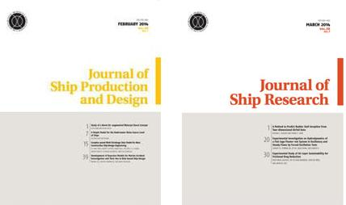

ALEXANDRIA, VIRGINIA (USA) – The Journal of Ship Production and Design (JSPD) published by the Society of Naval Architects and Marine Engineers (SNAME) has been accepted for coverage in the Thomson Reuters® Web of Science™ Index of Scholarly Literature.

The SNAME Journal of Ship Research has been indexed in the Web of Science for many years.

The Web of Science is widely recognized as the world’s leading source of scholarly research data. The index is the only interface to include subject-specific, unbiased, curated content on emerging trends based on citation activity of the most impactful global and regional journals, books and proceedings.

The quarterly SNAME Journal of Ship Production and Design (JSPD: ISSN# 2158-2866,
US $335.00, International $365.00, SNAME Members US $75.00, International, $90.00) features original and timely technical papers addressing problems of shipyard techniques and production of merchant and naval ships. The online edition of JSPD is available free to SNAME members. For information on SNAME membership, visit www.sname.org/membership1/joinrenewsnamemembership.

The quarterly SNAME Journal of Ship Research (JSR: ISSN# 0022-4502, US $335.00, International $365.00, SNAME Members US $80.00, International, $95.00) publishes highly technical papers on applied research in hydrodynamics, propulsion, ship motions, structures, and vibrations.

For more information about the Journal of Ship Production and Design, Journal of Ship Research and other SNAME publications, visit www.sname.org/pubs or contact Kristin Walker, kwalker@sname.org or 1+703.997.6710.

SNAME is an internationally recognized non-profit professional society of individual members serving the maritime and ocean industries. Founded in 1893, the Society comprises over 7,000 individuals around the world.

-0-

Society of Naval Architects & Marine Engineers – 99 Canal Center Plaza, Suite 310 - Alexandria, VA 22314

News release prepared by Home Port Marine Marketing
www.homeportmarine.com/productpr

